Y2Q2W6

The Kings Dream

Play: I'm thinking of a number…
Ask: Do we know what someone else is thinking?
Ask: Do you ever wish you could know what other people were thinking?
Say: Today we are learning about when King Nebuchadnezzar thought his advisors should know what he had dreamed about!
Bible Story – with magnet board
Sing Songs

Ask: Who knows what they would like to be when they grow up?
Say: When I was a kid I thought I would be a teacher or a mother, but by the time I finished high school, I had changed my mind.
Say: We can decide what we would like to happen in the future, and we can do things to help make it happen, but only one person really knows what will happen.
Ask: Who is that?
Ask: How do we know that God really does know? (Because it happened just like God said.)
Say: God gave the dream to King Nebuchadnezzar and Daniel back in 603BC. 65 years later, the Meads and Persians conquered Babylon. More than 200 years after that Alexander the Great took his army from Greece all the way to India! More than 160 years after that Rome took over. And it was the Romans who were in power when Jesus was on earth. The Roman Empire lasted a long time, (about 500 years) and it was the last time that such a big part of the world was ruled by one nation.

Return to tables
Memory Verse: Fill in the blanks and then say the memory verse on the colouring page and finish.

Say: This term we are going to make fridge magnets to tell the Bible stories with. You will keep your magnets in a special magnet book which we will loan to you until the end of the term and then you can take the magnets home – but we will keep the magnet books for next time. DO NOT DRAW OR WRITE ON THE MAGNET BOOKS

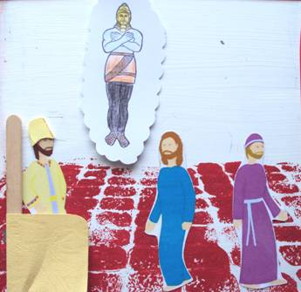
Magnet Books
- If they haven't already: Choose a magnet book. Write your name on a label and loop through handle. Hand out king, crown and prophet, and make a bed
- Colour in the statue and put a magnet on the back.
- Hand out the 2nd man.
- Attach seat square to paddle pop and cut a magnet in half and attach the 2 halves to the back of paddle pop to make a chair.

Discuss the following depending on age, interest and time:
How can people sometimes tell what other people are thinking? (Body language, thinking how they would feel etc)
What would you like to be when you grow up?
Do you know what you have to do to become that? (School, courses, experience etc?)
Have you ever had a dream and woke up and can't remember what the dream was about?
Discuss how the dream matches what really happened.

Optional Booklet: Colour the statue outline on the front then fold back on dotted lines. Glue the front to the back. Then open the flaps to see what each part represents.

Ask: Who is the best person to give us advice for the future?
Say: I hope that you will all choose to obey and follow God, so that you will have the best future possible.
Finish with prayer.

